Sponsor Opportunities Limited to 10 sponsors
Value $750.00
(Includes Exhibitor Booth space – value $200)

Includes: Pre-promotion on event poster, Chamber website, Business Matters newsletter, Chamber Social Media, Logo on welcome signs at the event, showcase at one Chamber member dinner.

Tuesday, November 5 1pm to 7pm
Parksville Community & Conference Centre
132 Jensen Ave. Parksville

The place to grow business, create opportunities, generate leads, make connections and showcase your business services. As an exhibitor, you have the chance to spread the word about your company services. You can explore business options, business solutions and meet the other business representatives.

2019 EXPO – Exhibitor Application Form

Company Name: Contact
Address : Phone
Email:
We supply: 6 ft. skirted display table + 2 chairs. We have only 15 spots that have electricity – please confirm if you need electricity. Yes☐ or No ☐
Single Booth $200 ☐ Double Booth $350 ☐ Sponsor ☐ (includes booth price)
We will have a breakout session and guest speaker (topic TBD)
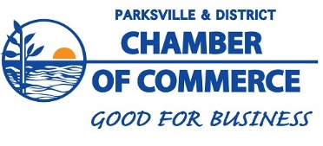
Island Highlander Food Truck onsite – will be offering coffee, tea, baked goods and light lunch

